1. In Gourand shading, the light gets calculated at every vertex using the vertex shader, with Phong shading, the light is calculated at every fragment with the fragment shader. In Gourand, the vertex color gets interpolated and with Phong, the 3 vectors are interpolated.

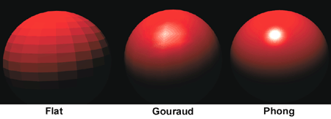

1. The Phong model uses 4 vectors to calculate color for a point p on a surface, it does this using vectors n, the normal of p, v, in the direction from p to the viewer, l is the direction from point p to an arbitrary point to the point light source, and r which is in the direction that a perfectly reflected ray from l would take.